E. TEMPERED CHORD WAVE PEAKS--C Major = C + E + G
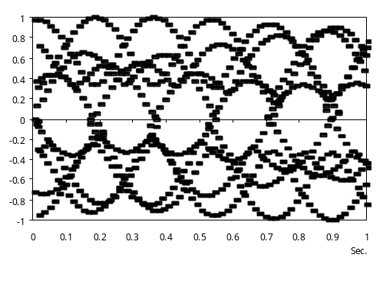
PIAGUI I CHORD WAVE PEAKS--C Major = C + E + G
